PYTHON MINI PROJECT REPORT
Pomodoro Study Session Timer

Course: Programming in Python
Project Title: Pomodoro Study Session Timer
Student Name: Aksa Kunjumon
Roll Number: 19
Class: S6 CS A
College: Amal Jyothi College of Engineering

Abstract

The Pomodoro Study Session Timer is a productivity application developed using Python and the Tkinter GUI library. The application allows students to manage their study time by setting a fixed duration for focused study sessions. The timer displays a live countdown along with a progress bar that visually represents the completion of the session. The user can start, pause, resume, and reset the timer using simple controls.

In addition to the basic timer functionality, the system stores completed study sessions in a CSV file and generates statistical charts showing total study hours, session durations, average session time, and total number of sessions. These statistics are visualized using graphs created with Matplotlib. The project demonstrates the use of Python for GUI programming, data storage, and data visualization in a simple productivity tool.

Problem Description
Students often struggle to maintain concentration during long study sessions. Without proper time management, productivity decreases and distractions increase. The Pomodoro technique is a popular time management method that divides work into focused time intervals followed by short breaks.
This project aims to develop a simple study timer that allows users to set a study duration and track their progress visually. The application provides an easy-to-use graphical interface where users can control the timer using different buttons. The system displays the remaining time and updates the progress bar during the session.
The main goal of this project is to demonstrate how Python can be used to build a simple graphical application that improves study productivity.

Libraries & Tools Used
Libraries Used
- tkinter – Used to create the graphical user interface including window, buttons, labels, and input fields.
- tkinter.ttk – Used to implement the progress bar widget.
- winsound – Used to generate alert sounds when the timer finishes.
- datetime – Used to calculate and display the study session finish time.
- random – Used to display random motivational messages when the timer ends.
- pandas – Used to store and read study session data from a CSV file.
- matplotlib – Used to generate statistical graphs of study sessions.
- os – Used to check if the session file exists before creating it.

System Design / Workflow

- The user enters the study time in minutes in the input field.
- When the Start button is clicked, the program converts the time into seconds.
- The countdown timer begins and updates every second using Tkinter’s after() method.
- The progress bar increases gradually as the time progresses.
- The user can pause, resume, or reset the timer using control buttons.
- When the timer reaches zero, the system plays an alert sound and displays a motivational message.
- The completed study session is saved in a CSV file.
- The user can click the Statistics button to view graphs showing study progress and session history.

Implementation Details
The program is implemented using Python and Tkinter to create the graphical interface. The timer logic is implemented using a countdown mechanism where minutes entered by the user are converted into seconds. The display updates every second using the Tkinter after() function.
Completed study sessions are stored in a CSV file using the Pandas library. This allows the application to keep a history of study sessions. When the user selects the Statistics option, the stored data is analyzed and visualized using Matplotlib graphs. These graphs display total study hours, session durations, average session duration, and the number of completed sessions.

Main Functions:
Start Timer – Initializes the timer and begins the countdown.
Update Timer – Updates the timer display and progress bar every second.
Pause Timer – Temporarily stops the countdown.
Resume Timer – Continues the timer from the paused state.
Reset Timer – Resets the timer and progress bar to the initial state.

Results & Output

The Pomodoro Study Timer runs successfully as a graphical desktop application. The interface allows the user to enter study time, start the timer, and track progress using the progress bar. Once the timer reaches zero, an alert sound and completion message are displayed.
The system also records study sessions and provides graphical statistics showing study performance over time. These graphs help users understand their study patterns and track productivity.
Screenshots to include in the report:
- Application start screen

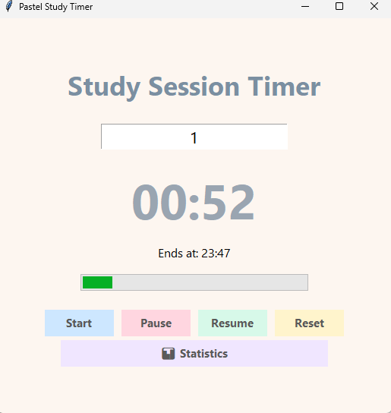
- Timer running with progress bar
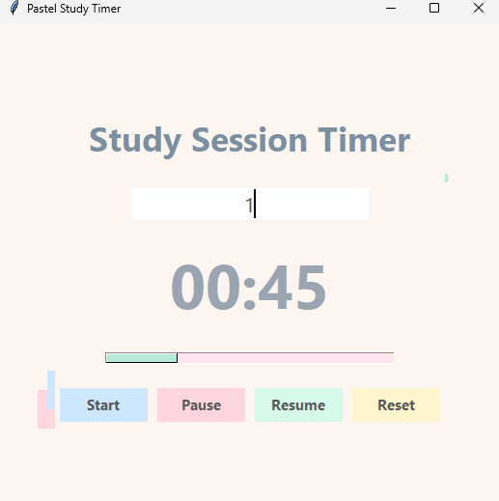
- Final completion message
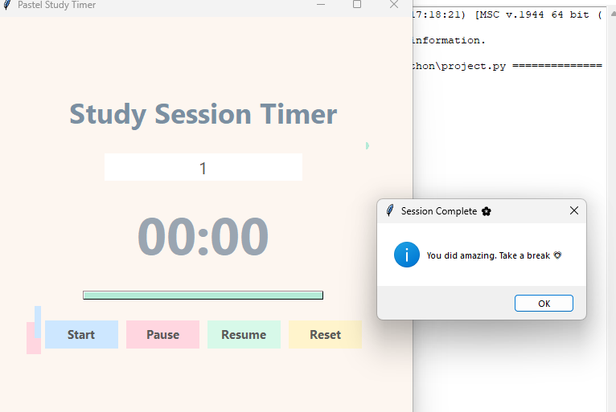

- Statistics graphs window
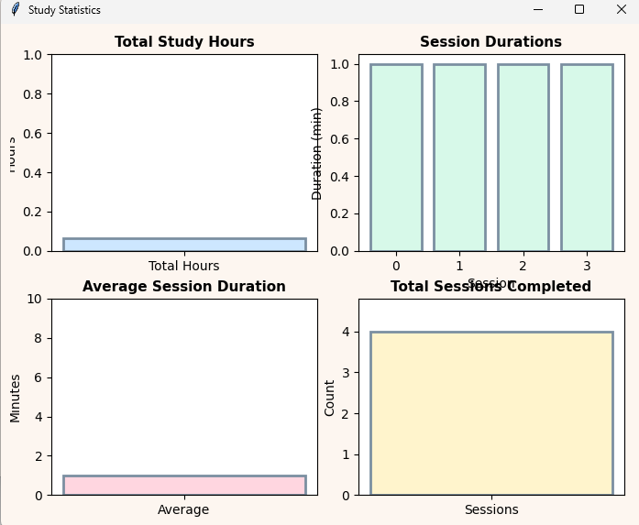

Conclusion
The Pomodoro Study Session Timer demonstrates how Python can be used to build simple and useful productivity tools. The project highlights the use of GUI programming with Tkinter and event-driven programming concepts. This application helps students manage their study sessions effectively.

Scope for Future Improvement
• Automatic break timers
• Study session history tracking
• Sound notifications and themes
• Mobile or web-based version

References
Python Official Documentation – https://docs.python.org
Tkinter Documentation – https://docs.python.org/3/library/tkinter.html

